WATER TESTING

Acidity and Alkalinity

• Place 5 mL of each water sample in a clean test tube.
• Test for pH using any of the following.

• pH meter - records directly.
• 3 drops of universal indicator - compare the colour of the solution with the chart.
• aquarium test strips - compare to the chart.

pH Scale 0 7 14
strong acid neutral strong alkaline
(red) (green) (purple)

WATER SAMPLE | pH | LEVEL OF ACIDITY / ALKALINITY  (0- 14)

Sulphate Ions (SO₄²⁻)

• Place 5 mL of each water sample in a clean test tube.
• Add 5 drops of barium chloride (BaCl₂) to each test tube.
• If a white precipitate (solid) forms, it contains sulphate ions.

WATER SAMPLE | SOLID  (yes/no) | LEVEL OF SULPHATE  (none, low, medium, high)

Salt - Chloride Ions (Cl¹⁻)

• Place 5 mL of each water sample in a clean test tube.
• Add 5 drops of silver nitrate (AgNO₃) - compare to the standard test tubes
(1%, 2%, 5% salt).

If a white precipitate (solid) forms, it contains chloride ions. Estimate the percentage of salt.

WATER SAMPLE | CONCENTRATION (%)

Phosphate Ions (PO₄³⁻)

• Place 5 mL of each water sample in a clean test tube.
• Use pool test kit strips to test each sample - compare to the chart.

WATER SAMPLE | LEVEL OF PHOSPHATE  (parts per million - ppm)
Nitrate ions (NO₃¹⁻⁾

• Use the aquarium test strips to record levels - compare to the chart.

WATER SAMPLE | LEVEL OF NITRATES  (parts per million - ppm)

Chlorine

• Use the aquarium test strips to record levels - compare to the chart.

WATER SAMPLE | LEVEL OF CHLORINE  (parts per million - ppm)

Alkalinity [carbonate ions (CO₃²⁻)]

• Use the aquarium test strips to record levels - compare to the chart.

WATER SAMPLE | ALKALINITY  (parts per million - ppm)
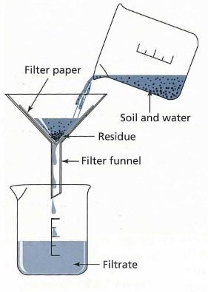
Suspended Materials

• Filter 20 mL of the water through a fine filter paper.
• Let the paper dry.
• Use a hand lens or stereo microscope to observe any trapped solids.
• Take a photo and add it to your report.

WATER SAMPLE | SOLID  (yes/no) | DESCRIPTION OF SOLIDS

Clarity (Turbidity)
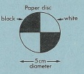
• Place 50 -100 mL of the water in a tall clear glass tube
(gas jar, measuring cylinder, etc).
• Place a black and white turbidity disc under the
bottom, or draw a black cross on a sheet of paper.
• Look at the disc or cross through the water.
• If the disc is easily seen, it has low or no turbidity.
If it is difficult to see, it has a moderate to
high turbidity.
• Take photos to show the clarity - add them to your report.

WATER SAMPLE | AMOUNT OF TURBIDITY

Conclusions

• Look at your results and rank the water samples from best to worst. Give reasons for your decision.

e.g. Too much salt (Cl¹⁻ ions), pH too high or low, etc.

• Use the following table to summarise your results to make it easier to judge.

Water Sample | Acidity  (pH) | Sulphate  (ppm) | Salt  (%) | Phosphate  (ppm) | Nitrate  (ppm) | Chlorine  (ppm) | Carbonate  (ppm)

WATER SAMPLE RANKING | REASONS
1.
2.
3.
4.
5.

